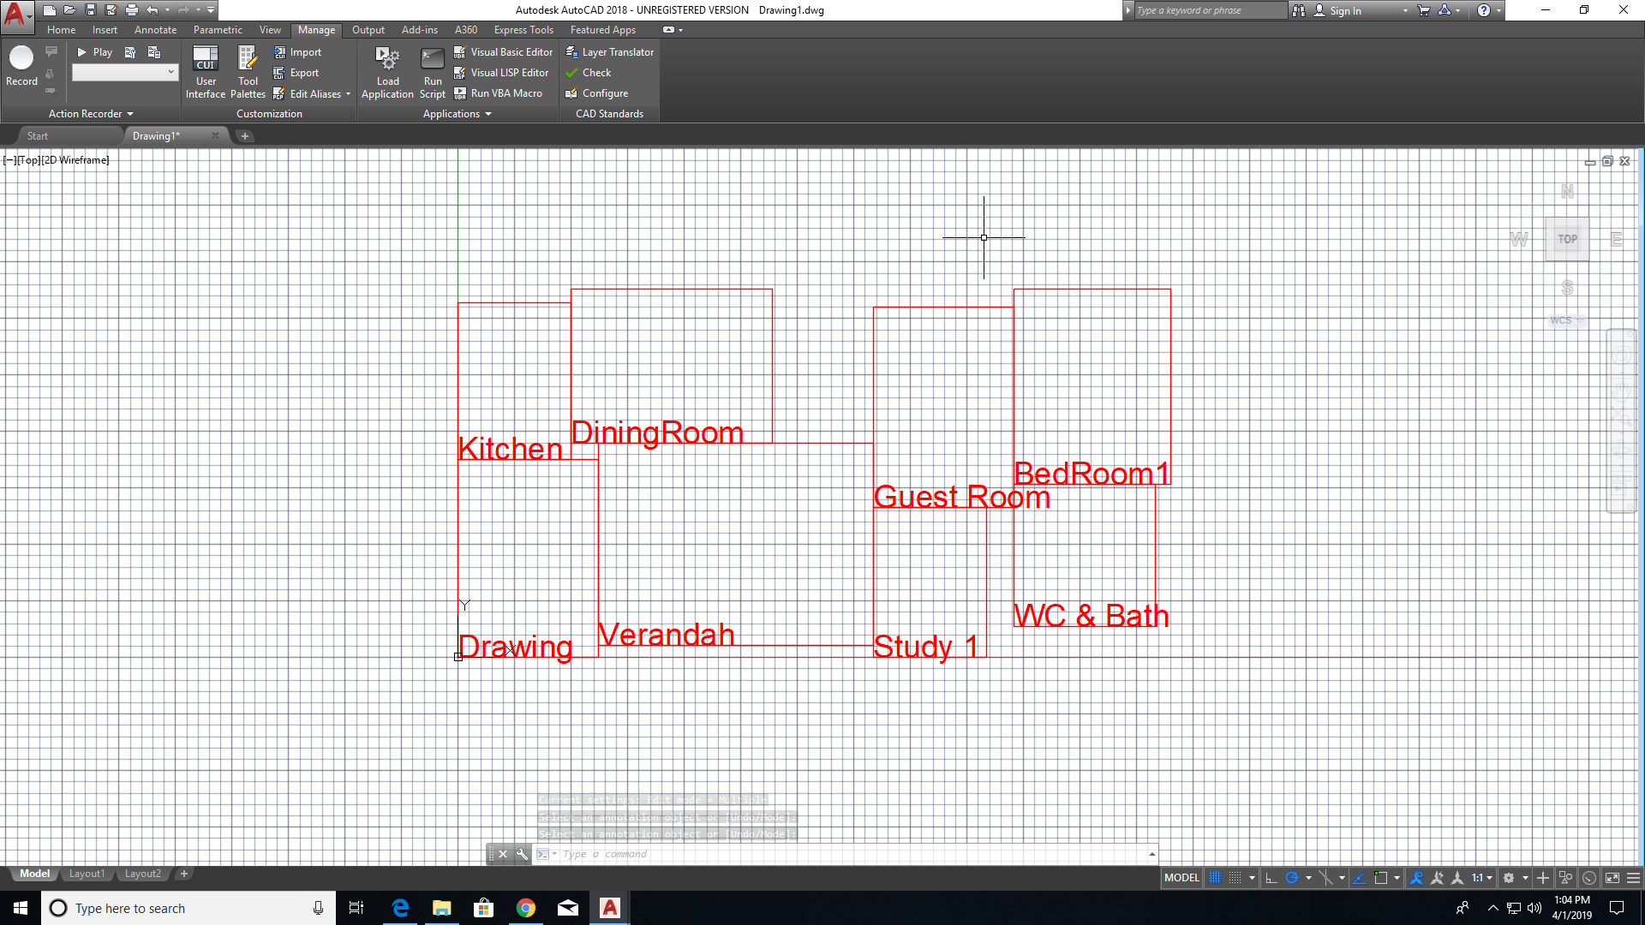

100Unique Fitness Population 1

161.172

170.308

max fitness_value chromosome 186.363186.363(((6 2) (3 5) (4 7) (0 1)) ((6.21955 4.99001) (8.91084 12.1637) (4.98004 6.18912) (6.95531 6.27446)) ((8.75414 6.95173) (6.81285 8.94604) (6.64421 8.87125) (8.62773 6.29591)))(6.21955 4.99001 8.91084 12.1637 4.98004 6.18912 6.95531 6.27446)

(8.75414 6.95173 6.81285 8.94604 6.64421 8.87125 8.62773 6.29591)

((6 2) (3 5) (4 7) (0 1))

((6.21955 4.99001) (13.9009 18.3832) (23.3633 24.5723) (31.5276 30.8468))31.5276LArea446.16642.8335

((6 2) (3 5) (4 7) (0 1))186.363

(6.21955 4.99001 8.91084 12.1637 4.98004 6.18912 6.95531 6.27446)

(8.75414 6.95173 6.81285 8.94604 6.64421 8.87125 8.62773 6.29591)